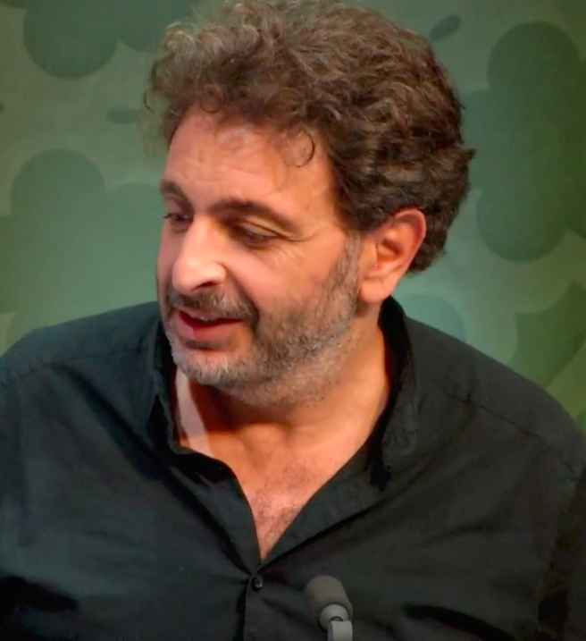
BIOGRAPHY
DAVID GUEZ

lartestunsouvenir@gmail.com
www.guez.org
67 rue des 4 ruelles, 93100, Montreuil, France
+33668377772
Maison des artistes : n° G841573
N° Siret : 414 777 490 000 31
BAC D/ MAITRISE INFORMATIQUE PARIS 6/ BEAUX ART RIETVELD ACADEMY/ D.U Astrophysique Paris

Since 1995, David Guez has carried out artistic projects whose two fundamental driving forces are:

- The notion of "link": social link, link between different mediums and between different practices, link associated with an idea of otherness where new technologies would be the means of exchanging with others.

- The notion of "public", in the most open sense of the term: "an art open and available to all audiences" and in the political and social sense: "an art which questions public and intimate freedoms and which offers alternatives" .

These two approaches allowed him to invent “objects” and “matrices” which question contemporary subjects and their links with new technologies and sciences. These include themes as varied as free media, psychoanalysis, the relationship with time, collaborative uses of the Internet, problems of identity, loss of freedom and questions of archiving. Since 2021, he has also written fictional stories.

These projects are exhibited in France and internationally in museums, art centers and universities and festivals (Centre Pompidou, Jeu de Paume, Gaiété lyrique, ISEA, Opéra Bastille, Laval Festival, Banff, etc.).

They have received numerous grants and prizes and, for some, acquisitions from museums and foundations.

WORKS

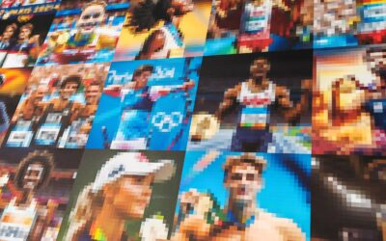
HPJO2024
Can artificial intelligence predict the future?
In this case the results of the 2024 Olympic Games. Exhibition at the Center Pompidou January/February 2024
Link

CAPSULE 2067
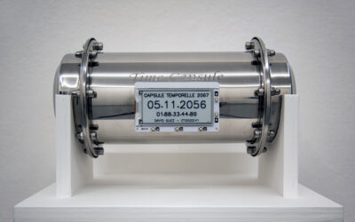
A time capsule whose opening date changes every day.

Link

EXOST1
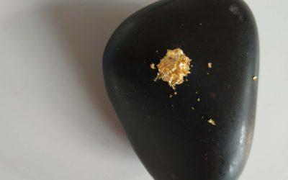
Stones that store memory elements passively.

Link

NFTIME
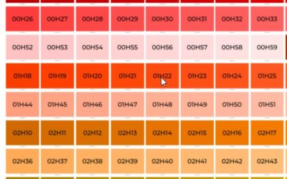
A series of NFTs which offers the segmentation of 24 hours into 1440 elements: http://www.guez.org/nftime

MYOWNDOCUMENTA
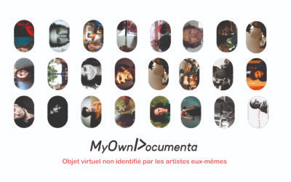
A 'collective logbook' platform that brings together more than a hundred artists and authors.
www.myowndocumenta.art

MNAOMAÏ
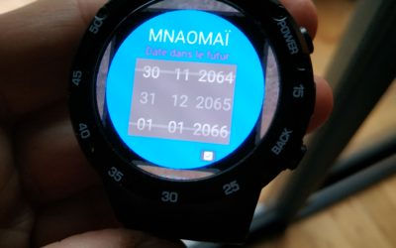
An augmented reality application that stores and restores geolocated fragments of memories.

Link

KRONOS
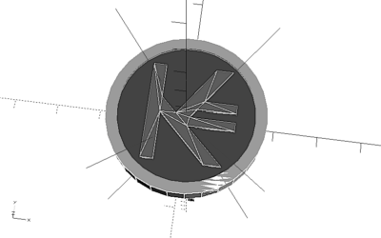
A currency whose basis of exchange is time, under Blockchain environment.

Link

VRLAB.FR

Collective that questions art and virtual reality.

Link

HOSTANARTIST
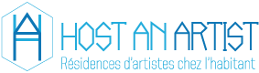
A community platform for artist residencies in local homes.
Hostanartist.com

LEVITATION
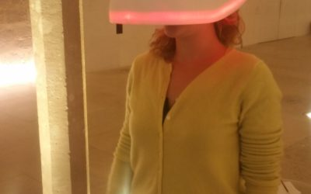
A virtual and augmented reality installation that plays on questions of vision and concentration via brain waves.

Link

ELIOT.AI
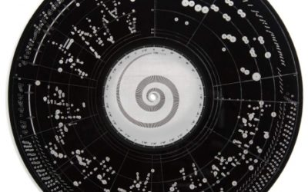
A collective intelligence which aims to combat artificial intelligence.

Link

HUMANPEDIA
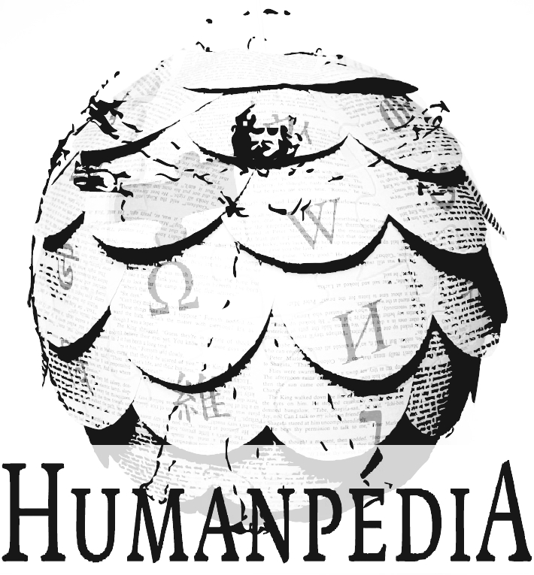
Humanpedia offers everyone the opportunity to participate in the creation of a universal memory outside of any technological context by orally sharing the great literary works of world heritage and all the encyclopedic knowledge represented by Wikipedia. Scam Prize 2011, Galerie du Jeu de Paume, Paris, 2009.

PAPER HARD DISK
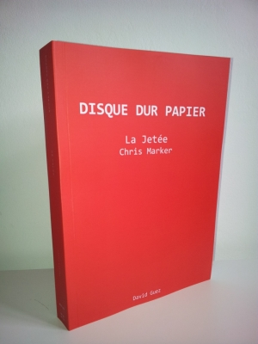
The paper hard drive offers the storage of digital data on a “paper” medium via the shrinkage of the computer code of the files, thus allowing long-term backup and a possible 'reload' in the event of the disappearance of the magnetic version.
DIGITAL MEMORY
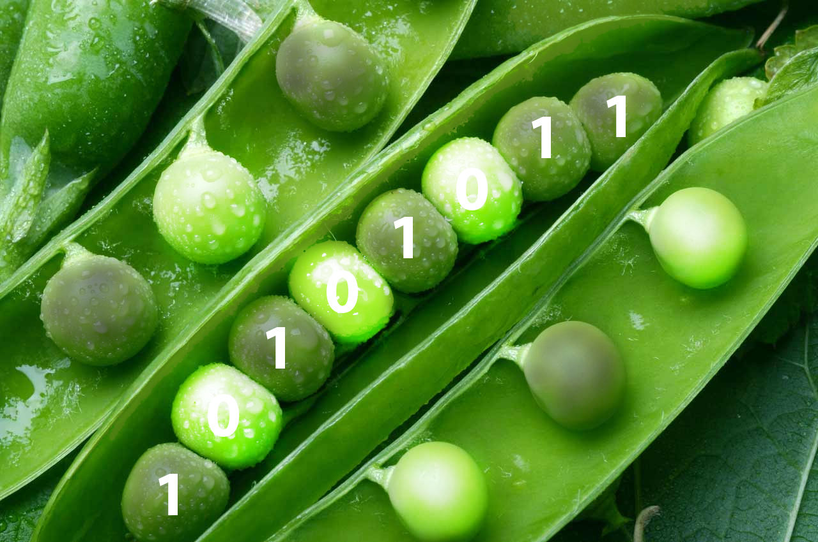
How to use Land art, genetics or reverse bioengineering to save our collective memory in the digital age”
Link

BINARY STELES
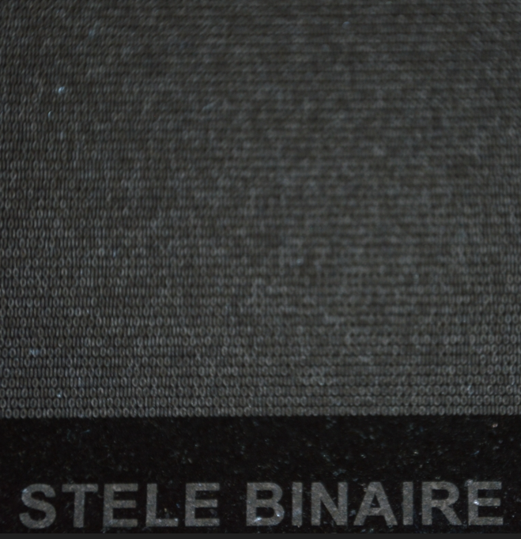
Binary steles are backups of digital documents on various perennial supports such as stone, aluminum or even in the form of mosaic frescoes.

Link

SERIES 2067 – 2067.FR
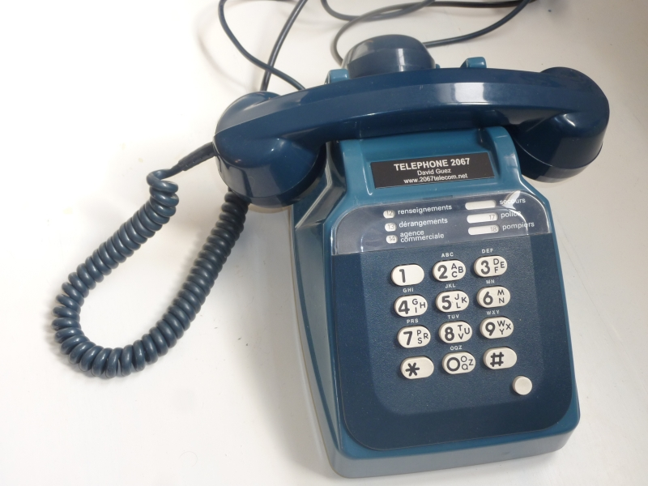
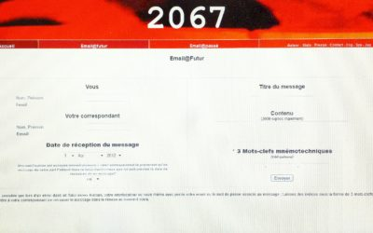
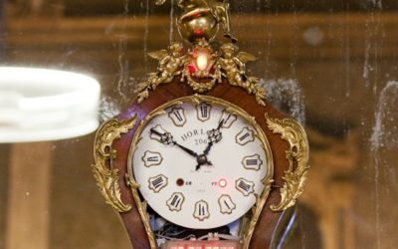
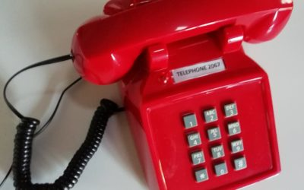
SERIE 2067 is a set of artistic proposals (installations, website, objects) which question time, memory and our intimate and collective relationship to these questions via social networks and new technologies.
EMAIL 2067 : A website allowing you to send an email in the future.
RADIO 2067 : A radio whose frequency line is replaced by a time line allowing historical listening to music from 1900 to 2012.
TELEPHONE 2067 : A network of telephone booths and handsets installed in public spaces which allow you to leave voice messages in the future.
CLOCK 2067 : A clock which permanently records the surrounding sound space and whose remote movement of an arm on the hands returns to listening to sequences from the past.
CAMERA 2067 : The 2067 camera is a particular photographic device which allows you to take photographic images which are sent immediately on the internet network -
DOTRED
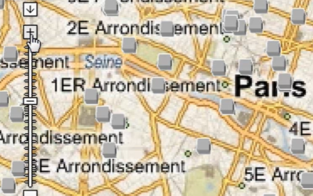
DotRed is a fun multi-player application on the Internet which brings together users around humanitarian and social actions by playing on the mass effect of social networks and highlighting the questions of transition from virtual to real.

TELEWEB
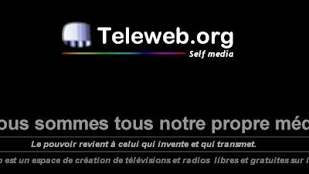
Teleweb is a free web television and radio portal which was offered between 1999 and 2001. The project brought together more than 2000 web TVs, on the principle of self-media.

TVART
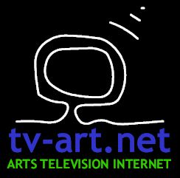
Tv-art.net is one of the first televisions on the Internet. It was created in 1999 and has distributed more than 500 video documents and offered carte blanche to artists and art mediators.

PODCAST : https://www.youtube.com/c/DavidGuez

PUBLICATION

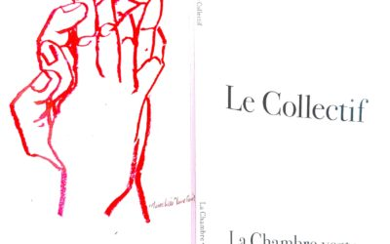
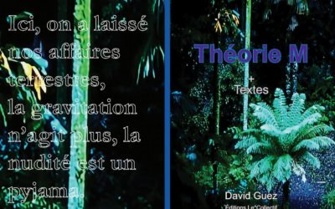
Collective

M-theory
EXHIBITIONS _

HPJO2024: Off-piste Festival, Center Pompidou, Paris, January/February 2024
Binary Stele & Paper Hard Drive 'Journey to the Moon': Exhibition, Bordeaux Montaigne University Congress, June 2023, Bordeaux.
1heure.net, white night, June 2023, it's a pink house, house of plastic arts Rosa Bonheur, chevilly la rue
Binary steles, interstice festival, May 2023, Esam Caen/Cherbourg
Project “1heure”, Exhibition 'It was too Beautiful', January 2023, Ivry.Seine.
Capsule 2067, Galerie Plateforme, Paris, October 2022, Paris.
The Collective, Soundbed, Auteuil Festival, Sept 2022, Auteuil.
Binary Stelae, Constellations Exhibition #2 , May 2021, Montbelliard.
MYOWNDOCUMENTA.ART, Sept 2020, Galerie Plateforme, Paris.
Auteuil Festival Exhibition: Oct 2021
Binary Steles, Constellations #2 Exhibition , May 2021
MYOWNDOCUMENTA.ART, Sept 2020, Platform Gallery
MYOWNDOCUMENTA.ART, Sept 2020, Auteuil Festival, France.
MYOWNDOCUMENTA.ART, August 2020, Festival 47, Brosses, France.
HARD DISK PAPER 'I LOVE YOU', Collective work ' Harddiskmuseum ',
Nov 2019, EP7, Paris
LEVITATION, BANFF SUMMIT, Nov 2019, Banff, Canada. Levitation exhibition, VIFF Festival, Vancouver, September 2019
“MOON” BINARY STELE, COSMOS Expo, April 13-July 20, 2019, Espace Gantner, France.
DICREAM SCHOLARSHIP, MNAOMAI Project.
Levitation, LAVAL VIRTUAL, March 2019
Kronos, conference, La gaiété Lyrique, New kids on the blockchain, February 2019
Radio 2069, Center Pompidou, February 2019
Exhibition tel 2067 and Radio 2067, Maison Guerlain, Paris, October-Nov 2018
Exhibition Series 2067, Zinc, Chronicle 2018, Marseille, October 2018
Radio 2067 exhibition, Espace Caussimon, October 2018.
Levitation exhibition, Futur.es, La villette, Paris, June 2018.
Levitation exhibition, IX Symposium, SAT, Montreal, May 2018.
Levitation exhibition, ZERO1 Festival, La Rochelle, April 2018
Conference on Levitation, Ecole du Louvre, Paris, March 2018
“LEVITATION” exhibition at the b3 festival, Frankfurt, Germany, November 2018
Conference Paris 8, Seine St Denis, Oct 2017.
ELIOT project presentation, Opéra Bastille, Sept 2017.
Exhibition Hard Disk Paper, Time, Society, Brussels, Sept 2017.
Levitation exhibition, Collège des Bernardins, Paris, France, Dec 2017
Series 2067, Philonum, Center Pompidou, Paris, Jan 2017 Kronos, I
MA L
art center / Belgium, Nov 2017 Kronos selected for the Ricx Festival , Sept 2016
Levitation exhibition / Korea, Aug 2016
Hostanartist , NICE festival / Germany, Aug 2016
CNC-DICREAM production grant for Levitation – Vrlab, July 2016
KRONOS project Selected at ISEA 2016, May 2016
LEVIATION, Digital Baths Festival & Hémisphère festival, Enghiens, April/July 2016.
Anachronism Festival, Espace Gantner, Montbéliard, April 2016
Series 2067, Digital Baths Festival, Maison des arts D’Enghiens les Bains, April/May 2016
Levitation exhibition, Exit Festival, Maison des arts de Créteil, April 2016
Email 2067, Center Pompidou, March 2016
“Interviews” Festival, Belfort, Dec 2015.
“Vita nova” Festival, Paris, September 2015.
Series 2067, Festival “Science of art in Essonne”, Juvisy sur Orge, Nov 2015.
Camera 2067, “ISEA 2015” Festival, Vancouver, Canada, August 2015.
“Virtual Reality & Connected Brains” exhibition, Google Institute Lab, Paris, May 2015.
Anachronism exhibition, Center Imal, Brussels, Belgium, April 2015.
Exhibition “Virtual Reality, Art and Alterity”, Google Institute Lab, Paris, March 2015.
Exhibition “Vrlab, art and virtual reality”, Gaité lyrique, Nov 2015.
“ISEA 2014” Festival, Dubai, United Arab Emirates, Oct 2014.
Personal exhibition, “Chemins Electroniques” Festival, Acce(s), Pau, May 2014.
“Empreintes Numériques” Festival, Toulouse, April 2014.
Collective exhibition “Manifesto degree 48”, Les labos D’aubervilliers, Aubervillers, Nov 2013.
“Show Off” Festival, Fiac, Espace Cardin, Paris, Oct 2013.
Personal exhibition, Maison Populaire, Montreuil, Sept-Dec 2013.
“Rencontres Frasq” exhibition, Le Générique, Gentilly, Oct 2013.
“Declic” Festival, Nanterre, Oct 2013.
Humanpédia exhibition, Jeu de Paume, Paris, April 2013.
Collective exhibition, Galerie de Roussan, Paris, May 2013.
“Moments Of Inventions” Festival, Nancy, May 2013.
“Zonedream” Festival, Gaité Lyrique, Paris, May 2013.
“Bouillant #5” Festival, Rennes, April/May 2013.
“Hors piste” Festival, Center Pompidou, Jan-Feb 2013.
“Show off” festival, La Fiac, Paris, Oct 2012.
Exhibition “The night of the museums”, Museum of Fine Arts of Nantes, June 2012.
“DigitalChoc” Festival, Franco-Japanese Institute, Tokyo, June 2012.
“Taste the Future” Festival, Henin Beaumont, June 2012.
“2062” exhibition, Gaité Lyrique, Paris, March 2012.
Permanent exhibition Clock 2067, Gaité Lyrique, Paris, 2012-2014
Digital Exhibition, Le Lieu Multiple, Poitiers, 2011-2012.
Personal exhibition: “The future is coming to us at the same time”, Galerie Plateforme, Paris, June 2011.
Festival de l'Orme, Le Zinc, Marseille, March 2011.
Enghiens les Bains Festival, June 2010.
Exhibition “the worst is never certain”, Galerie des Beaux-arts de Metz, May 2010.
“Lift” exhibition, Marseille, June 2010.
“ISEA2009” Festival, Belfast, Northern Ireland, August 2009.
NextGen exhibition at 104, Paris, Oct 2009.
“Another story” festival, Meudon art center, February 2009.
Espace des Blancs Manteaux Festival, Paris, Nov 2008.
“Reality” Festival, Virtual Worlds, Paris, November 2008.
“Nuit Numérique” Festival, Reims, Oct 2008.
Nuit Blanche 2008, Center Fleury, Barbara Goutte d’or, Oct 2008.
Production & Exhibition DOTRED project, Center Pompidou, Paris, May 2008.
“Videoforms” Festival, Clermont Ferrand, March 2008.
Performance RG2012, Internet Mon Amour, Center Pompidou, Paris, Feb 2008.
Nuit blanche exhibition, Hotel d’Albret, Paris, Oct 2007.
Exhibition, 00130gallery, Helsinky, Finland, 2007.
Personal Exhibition “XOR”, Gallery of Young Creation, Paris, June 2006.
“File” Festival, Brazil, 2006
“Version>04” Festival, Chicago, USA, 2004.
“T-Deus” Festival, Brussels, Belgium, April 2004.
Collective exhibition, Console, Paris, April 2004.
“HEROESSE” exhibition, The Hall of Fine Arts of Lyon, Lyon, 2001.
Expo Collective - Personal diary of “KIM WINGSENG”, Palais de Tokyo, Paris, 2001.
Exhibition “the cinemas of tomorrow”, Center Pompidou, Paris, 2001.
“Free biennial”, New York, United States, 2001.
“Viper” Festival, Basel, Switzerland, 2000.
“International New Cinema & New Media” Festival, Montreal, 2000.
WWVF “world wide video festival”, Amsterdam, 2000.
“Net.congestion” Festival, Amsterdam, Netherlands, 2000.
“European Media art festival”, Osnabruck, Germany, 2000.
“Version 2000” Festival, Center for Contemporary Image, Geneva, Switzerland, 2000.
Collective exhibition, Galerie Public, Paris, 1999.
“Ouverture 4” Festival, Château de Bionnay, 1999.
FIAC 1999 exhibition, Stand of the Ministry of Culture, DAP, 1999.
Collective exhibition, TV WONDERLAND, Tasty Nights of Belfort, 1999.
Collective exhibition, Performance/Installation “Beauty Cream If I were you”, Atheneum, Dijon, 1999.
Personal exhibition “Beauty cream If I were you”, Galerie du Web Bar, Paris, 1999.
Personal exhibition “The days keep me asleep”, Galerie du Web Bar, Paris, 1999.
Collective exhibition “Les caramels Eden Eden”, Parthenay, 1997.

Conferences/Workshops
Google lab institute conference, Virtual reality and otherness, Paris, March 2015.
Conference, Manifesto degree 48, Les labs D'aubervilliers, November 15, 2013.
Conference at the National Audiovisual Institute, Paris, April 2013.
WorkShop Fine arts of Marseille, March 2013.
ENSAD PARIS Conference/Workshop, March 2012.
Franco-Japanese Institute Conference, February 2012.
Conference on RG2012, Maison des arts de Malakoff, Nov 2008.
Lorient Fine Arts Conference, Dec 2011.
Workshop at Arts-Déco in Strasbourg, April 2010.
Conference at EHESS/café des sciences, Paris, February 2010.
Conference at the Maison des metallos, Futurs en Seine, Paris, June 2009.
Workshop & conference, “Festival K3”, Lorient, March 2009.
Cité des sciences conference, La Villette, Paris, Dec 2008.
“UPgrade” festival conference, Maison Pop, Montreuil, Nov 2008.
DotRed Conference, Nuitdigital Festival, Reims, Oct 2008.
Conference Higher School of Architecture and Graphic Art, Ivry, Oct 2008.
DotRed Conference: Forum for cooperative uses, Brest, July 2008.
Conference “The net and money: the DotRed experience”, Le plateau, Frac Ile de France, July 2008.
Conference at the Pompidou Center “DotRed”, May 2008.
Conference at the Carrefour des Possibilities, La Fing, Paris, May 2008.
Conference on “Social networks”, Vidéoformes, Clermont-Ferrand, March 2008.
“Internet mon amour” cycle conference, Center Pompidou, Paris, February 2008.
Presentation of the “2067” project by Annick Rivoire, BNF, Paris, 2007.
Conference at the Fine Arts of Dijon, March 2004.
“Network Workshop” conference, Digital Flaherty, New York, United States, 2001.
Preload Conference, St Charles, Paris I, 2000.
Conference, Forum des images, Paris, 2000.
Nantes Fine Arts Workshop, 1999.
Conference, The milky voice, Terres Blanches, Montbéliard, 1998.
Conference at Accès local, Paris, 1998.
SAGA Conference - Art in Networks, Paris, 1996.
Conference “The book of links”, MILIA, Paris, 1996.

Publications
Cosmos Magazine, 2019
Neural Review, April 2013 – Humanpedia, printing error (English).
Poptronics.fr: boot series: 10 audio articles: 2010
Poptronics.fr: nextgen series: 12 items.
Dotred booklet, 2008, Center Pompidou.
Carte blanche release: Launch of 1400cm3, 2006.
Slunk Magazine: Xor, art is a memory, 2006.
Art scenes, number 13 “We are all our own media”, 2001.
Doc(k)s review, series 3: Teleweb, “we are all our own media”
Publication in the POST magazine “the Arabic telephone: towards a new media? »,2000.

Residential homes
Residence at Crane, Chevigny, July 2013.
Gaité lyrique, 2012 - Production residency over 1 year - Horloge Creation 2067.
Databaz Center, Angoulème, June 2010 - Humanpédia Residence.
DOTRED project creation residency, Center Pompidou, Paris, 2008.
Interactive screen. BANFF, Canada, 2001.
Residency at CICV, Montbéliard, 1996.

Media
International Press : New York Times (US), EL PAIS, Le Soir (Belgium), Siol (Slovenia), BandNewsfm (Brazil), International Herald tribune (US), Esp (China), Haaretz (Israel), Cotidianul (Romania), Referans (Turkey), Chicago suntime (US), ABCNews(US), Deutschwell(German Radio), DZ(Algeria).
National press : Le Monde, Télérama, Beaux-arts Mag, Les Inrockuptibles, Ecrans.fr, Métro, Libération, La Tribune, Le Point, Transfer, Broadcast, L'internaute, Marianne, SVM, DigitalNews, Newsmédias, Netsurf, Tribeca, Télérama, Camera,Le Journal du Dimanche, chronicart.
Radio : France Culture, France Inter, Rtbf1, France bleu, BFM...
Television : CANAL +, NPA I, France 5, Paris Première, RiveDroite/Rive Gauche
Book : Art and Internet, “imaginary: instructions for use” collection published by art circle.

Grants/Awards
Dicream Scholarship 2019, Manomai project
Dicream Scholarship, 2013
Dicream Scholarship – 2011/12.
Arcadi Scholarship, 2011/12.
Scam Prize, dream of a digital draft, 2011.
Production assistance - CNC – Dicréam, 2008.
Scam Prize, dream of a digital draft, 2008.
Dicream scholarship, Hypermoi project, CNC, 2007.
Scam Prize, 2000.
DAP grant, Tv-art.net, 1999.

Acquisition
Paper Hard Drive “La pier”, Kandinsky Library, Center Pompidou, March 2013.
Binary Stelae, Espace Gantner, Montbéliard, 2014.

