KRONOS PROJECT
David Guez

Description of the project (250 words max)
The Kronos project proposes the creation of a currency whose index is based on human time. Thus, a unit of that currency, one Kronos, corresponds to one hour spent on an activity by a person or a group of people.
The kronos project will be developped into a decentralised and secure exchange system ie the blockchain system.
The Kronos is placed in a logic of peer to peer and common goods.
http://www.kronos.money
Technical and exhibition requirements
- Presentation of the concept
- Presentation of the V1
- Possible of workshop around extended ideas around the concept.
Budget/ production cost
The idea is to realize the v1 of the project on the ethereum blockchain system and a prototype of a connected wallet object linked to the kronos process of exchanging between people. If this budget is
too expensive, I can come to present it and to exchange (talks, workshop) around it.
The cost is :
1500 euros for computer developpers.
1500 euros for the electronics proto.

Drawings


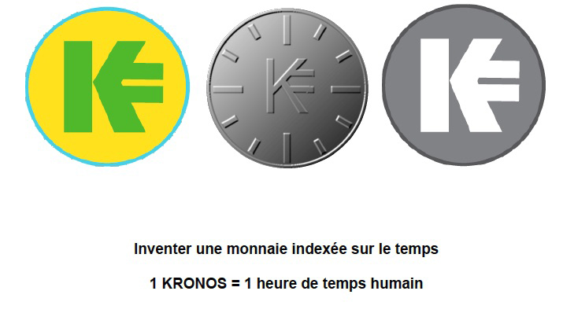

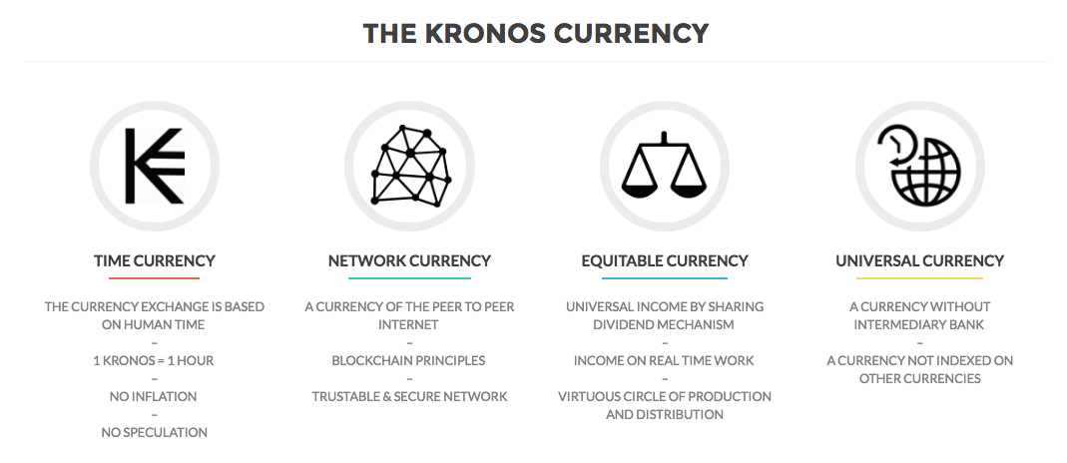
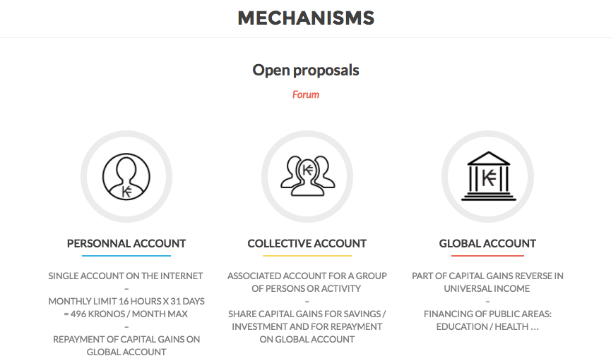

List of people involved and credits
David Guez
Links related to the work
Kronos website
www.kronos.money
Kronos manifesto
http://www.kronos.money/KRONOS-ONLY-EN.pdf
Kronos presentation (pdf)
http://www.kronos.money/KRONOS PRESENTATION_EN.pdf
Credits
David Guez
Contact details (email, phone, postal address)
David Guez
david@guez.org
0033668377772
67 rue des 4 ruelles, 93100 Montreuil
Short bio of the creator or the group (up to 150 words)
David Guez realizes artistic projects related to new medias that mainly focus on the themes of memory and time. He also worked on the realization of many collaborative platforms which question the uses and limitations of new technologies while offering new alternatives.
These projects are produced and present in many art center (Center Pompidou, Jeu de paume Gaité lyrique, Banff, File Festival Brazil, ISEA 2015/2016…) and receive media coverage (New york times, the world, release, Télérama, France-culture…) and french institutional support.
http://www.guez.org

